CUSTOM API FROM SCRATCH

### Project Context

Using all of the skills you’ve developed over the last two trimesters, you’re going to team up with a partner in creating your very own API from start to finish. You’ll develop a design, narrow down what should be in your MVP (minimum viable product), and work together as a team to bring your idea to life. You have a limited number of days to work on this project, so be sure to keep your scope reasonable for you and your team.

### Challenge

There is one rule that must be followed…your application must follow the theme, ***“What’s Outside?”.*** You and your team are free to interpret that in any way you see fit (keep it Safe For Work, though)!

### Manual Review

When manually reviewing your peers, have them share with you (on their local computer) the API that they built. This will make reviewing easier than trying to set up their database and API on your local system. What this means when developing your API/database is to make sure that everything runs locally so that the manual review process is straightforward.

### Final Note

You are expected to have this project run locally on your machine (or sandbox environment), but you are welcome to find a way to host this online for your own purposes (especially if you wish to share this with others). If you choose to host this online, there is definitely a free/cheap way to do so, so be sure to look at the tools you are interested in using and verify their functionality as well as pricing model. Many tools online have a free tier that would be more than sufficient for this project.

THEME: ***What’s Outside?***

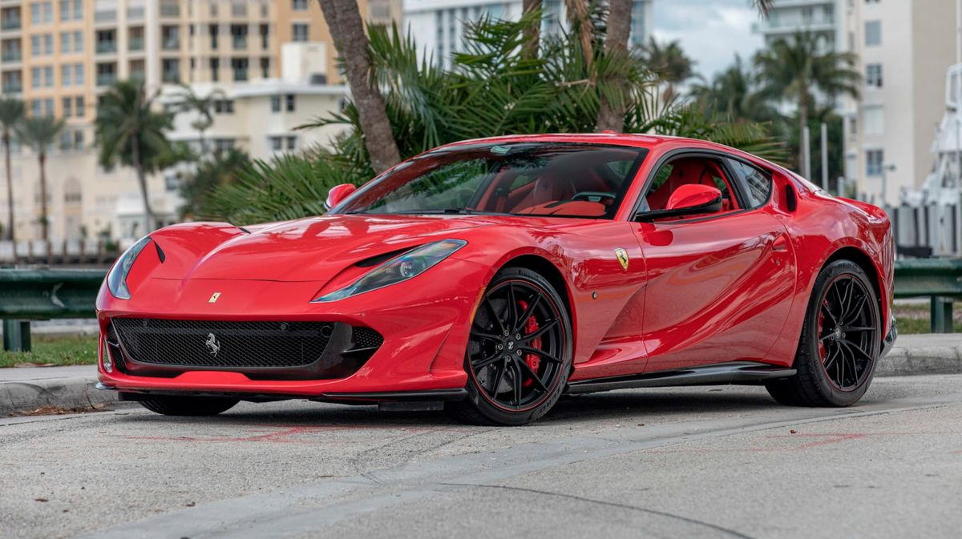

*MERCURY SPORTS AUCTION*

* From ancient Roman mythology, Mercury was associated with being the roman God of speed

Writeup: I will be building an **application that hosts a luxury sports car auction**, providing users with the option to view selections available in the auction on the client side of the UI, and the functionality to be able to filter out what is available through the database that is connected to the API.

* This fits the theme because the sports car auction is held in an outdoor event space, and sports cars are driven outside.
* Tools likely to be used: undecided
* Expected to spend majority of allotted project time on the API development, and save outlining tasks, or allot time equivalent to one or two days for the others.
* API documentation will be listed in the README.md of the project.
* Database documentation: *next page*

